Wise Words: Hate Drafting and Barcelona
Gary Wise
Wow, did I suck in Barcelona. Magic players will make all the shortsighted excuses in the world, but not this hombre, at least not this time. In Barcelona I was awful, probably worse than at any time in my Pro Tour career.
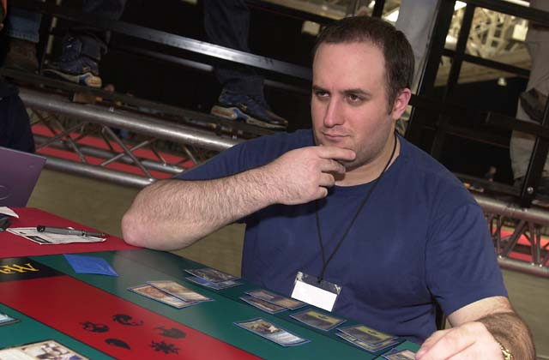
En route to going 6-8 (that includes a bye, by the way), I managed to take Mike Bregoli out of the Pro Tour, lose thousands of dollars on one stupid play in the Masters, lose around six matches purely on player error, screw up two of my four drafts within the first few picks and bring into question my entire self-confidence with regards to the playing of this game. Not a very good weekend, but at least I succeeded in one respect with regards to the goals I set going into my trip overseas.
You see, in making the decision to head off to England before Spain, I failed to realize I'd be cutting myself off from one of the entertainment spectacles of this still-young millennium. Not only would I be missing the final episode of Survivor, but I'd also be missing the penultimate episode, which many of my Pro Tour comrades would have seen and, knowing about my passion for the show, would want to gossip with me about. These were all difficulties of epic proportion.
For those of you not living on this side of the Atlantic, Survivor is the reality television show which set all kinds of ratings records last summer and continues its success now, having just completed its second season. Based off of the Dutch Expedition Robinson, the show sees sixteen Americans from assorted ethic, educational and financial backgrounds dumped in some remote location (this time it was the Australian Outback), with one of their number voted off the show by their peers each week. The one who remains at the end is declared the ultimate survivor, a distinction that merits a million dollar reward.
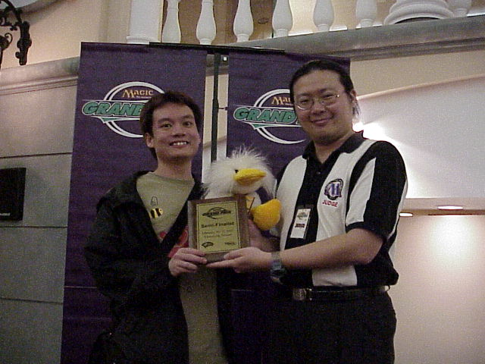
Whenever anything goes wrong, we blame Nick Wong's duck
While the weekend was far from successful as far as Magic goes, I was able to avoid gathering that pivotal information regarding which castaway was turfed in the second to last show and which of the remaining three eventually won, but it wasn't easy. The moment I walked into the room in which the gateway was being held, an anxious Mark Rosewater approached me about the show, forcing me to caution him before the conversation even started that I didn't want to know who the final three contestants were. When Nick Wong asked me two days later 'Gary, do you watch Survivor?' my reaction was to hurdle the rope barricades strung throughout the room (no easy feat for a man of my stature) and run as fast as I could to get out of earshot of any information that might be spilling from his lips. Finally, after the weekend had ended, and three days later, I arrived home, jetlagged, exhausted, sick, grumpy and fatigued and proceeded to watch in silence as my fingernails whittled themselves to the nub.
Now here's the thing: It shocks me how few top-level Magic players watch this show if for no other reason than Survivor is an amazing game. Combining basic survival skills with those of a more interpersonal and political nature, it is neither the quickest nor the strongest who wins in this game, as evidenced by the fact a 41 year old housewife, Tina beat the physically dominant 27 year old Colby to end this season's contest. Instead, it is that person who manages to maneuver himself or herself most efficiently so as not to anger anyone while gaining political power enough to keep themselves aloft who emerges victorious. Sound familiar?
With the passing of Barcelona, the final Pro Tour stop before World Championships, we now arrive upon what may be the most exciting portion of the Magic year. The National Championships season sees not only the combining of Constructed and Limited prowess, but also the pride involved with the right to wave one's national flag at World Championships. In almost every country in which this game is played, we, its players, will gather in the hopes of earning the title of Champion, and this year, as luck would have it, we will be fighting for the right to do this using the most skill intensive of all sanctioned Limited formats, Rochester Draft.
For those of you who have never done it before, Rochester Draft, like Booster Draft, involves the drafting of three packs per player. Instead of eight packs being opened simultaneously, however, only one pack is opened at any time, with the fifteen cards in that pack spread out over the table. Starting with the player who opened the pack, players (going clockwise around the table) select a card of their choice until each player has chosen, at which time the draft order reverses until all fifteen cards have been drafted. The player to the initial pack opener's left opens the next pack, and the process is repeated. After each person has opened a pack, the draft order reverses itself, going counter-clockwise until all participants have opened two packs, at which point the order reverses itself once again, with the draft completed when each player has opened three packs.
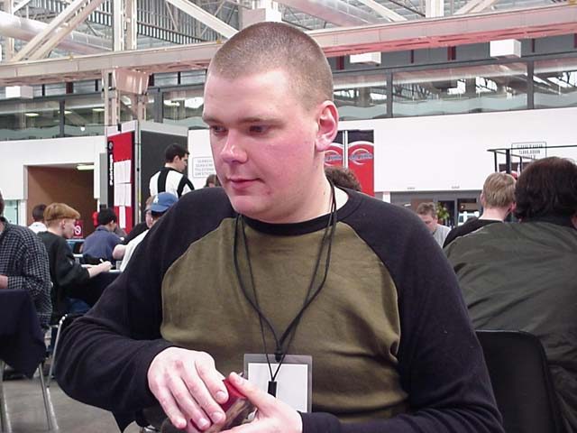
Who hate drafts Goblin Masons?
Like Survivor, Rochester Draft rewards those who know their game, help their friends and pacify their enemies. Where in Booster Draft, one's actions go virtually unnoticed and therefore unpunished, in Rochester Draft you are constantly under scrutiny. One of the more famous blow ups in PT history came when Sigurd Eskeland hate drafted a Goblin Masons from then teammate Randy Buehler with four cards left in the first draft of Worlds '99. In Booster, this assault would have gone off without a hitch, but with Randy seeing Sigurd's strike against him, he made sure the Big Viking felt his wrath. "F--- you if you think you're getting an Extended deck!" yelled Buehler. For this, Randy received the only warning of his pro career, and Sigurd enough stress to make some men's hair fall out. (Randy eventually consented to give Sigurd the deck, after the Rochester portion had taken both players out of the running for Top 8).
It's because of the potential for responses like this that one must understand the delicate political balance involved in this format. Yes, there will be times that you'll want to consider hate drafting during a Rochester, but when your neighbor is being cooperative, staying away from your colors as you are theirs, when you upset them with a hate pick, you risk bringing that back on yourself. Where once there was a non-verbal cooperative agreement, now that allegiance is shattered, and worse, the person you betrayed might now be seeking vengeance.
With this in mind, one strategy you may want to employ is to approach the draft as if the players on your immediate left and right are your teammates, at least until the last few packs of the draft. If you and your neighbors are cooperative while those players on the other side of the table fight among themselves, its more likely than not that your deck will be better than those on the other side of the table, so you should do very well.
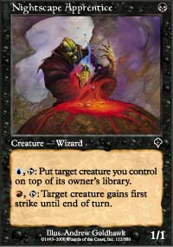
Of course, the possibility of this friendly approach will depend in part on those around you. Some players won't be cooperative, be it through strategic or political differences. It is in these situations that the skills required to be a strong Rochester drafter really assert themselves. The other day, I was doing a Rochester Draft where my neighbor to the right (sitting in the 5th seat) selected Nightscape Apprentice, generally a b-r card, so I took a Tidal Visionary. With his second and third picks, that neighbor then took blue and white cards, meaning my original plan to go blue-white behind a black-red player had been trashed, so I adjusted and quickly became a red-green player, understanding that my first few picks would have to go to waste so that my final forty cards would be chosen without being hindered by the drafter in front of me. The ability to adjust in this way will often be the difference between a solid draft and an awful one.
With regards to the colors you draft, there are a few factors to consider. First off, while in Booster Draft it's hard to communicate, the ability to do so in Rochester should factor heavily in how you go about establishing your colors. In Rochester draft, each pick you make should be made with the understanding that with the selection of any given card you are providing those around you with information about how you are drafting your deck. Here's an example:
The first booster pack of your draft is opened and the contents are Dueling Grounds, Alloy Golem, Tolarian Emissary, Voracious Cobra, Shivan Zombie, Obsidian Acolyte, Metathran Zombie, Crown of Flames, Shackles, Ancient Kavu, Faerie Squadron, Urborg Skeleton, Capashen Unicorn, Turf Wound and Reviving Dose. The player in seat one takes the Faerie Squadron, the player in seat two the Shivan Zombie, and those are followed in order by Shackles, Alloy Golem, Obsidian Acolyte and Ancient Kavu (this is all hypothetical, by the way. The order of picks only goes to help my point).
Now, in this scenario, it's your pick in seat seven, with the best remaining card obviously being Voracious Cobra. Now, you could take the Cobra and assume the mantle of red-green player, but you do have another option. While Metathran Zombie is by no means optimal or as good as the Cobra, it is playable, and you can use it as a communication method, telling those around you that you plan on playing blue-black.
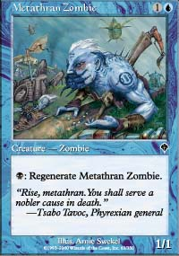
In addition to forcing preferred colors, there is another reason to consider taking the Zombie in this scenario. Regardless of whether you prefer drafting blue-black, it is generally agreed that in a format where you know what everyone is drafting, its best to try to position yourself in such a way that you get as many 'first picks' as possible. You may be saying to yourself that each player only gets three such picks, but once colors are established, a player generally won't pick cards outside of their colors, meaning that oft-times you'll have the first crack at cards in your color combo even though you aren't picking first in a given pack.
If in the above scenario you pick the Metathran Zombie, you'll be taking a card in a color combination that came out of the blocks pretty slowly in this draft, with only one quality card in either black or blue. With the player in front of you declaring red with the Kavu, in two thirds of the packs in the draft, you'll only get the second best red card if you take the Cobra. Likewise, by passing the Cobra to a player who is now sitting between two blue players (you pick the Zombie, the player in seat one picked the Faerie Squadron) you virtually assure that they won't be going blue, so in the first pack of the second round of boosters, you're virtually assured 'first pick' of the blue cards.
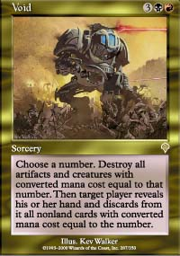
Now, I'm making a lot of assumptions about getting extra first picks considering that often the opening of a power card can change the course of any given draft. The reason for this attitude is because despite the fact some people do it, picking a powerful card you won't be able to play over a mediocre one you will play is just plain dumb. Say you're blue-white and passing to a red-black player. In the second set of boosters, your colors firmly established, you open a pack with a solid creature, Tower Drake, that could easily be played in your deck, and a power card, Void, which your mana base just can't handle. Now yes, Void could hurt you a lot if played against you, but the odds of that happening just aren't very good. First off, in most drafts, you'll only play 3 of the 7 players drafting with you, meaning more often than not you won't be playing that person who gets the Void. On top of that, if you do play them, the odds of their drawing Void aren't better than 50% in any one game, and on top of that, the odds of the card being drawn in an optimal situation are even lesser. By taking that card from your red-black neighbor, not only are you hurting your neighbor's deck, virtually assuring retaliation, but you're hurting your own deck by costing yourself a quality card that could see play if picked. Even if the blue-white card were something lesser, a Shoreline Raider for example, the odds of it helping you at some point far outweigh the odds of the Void hurting you. Take the best card for your deck.
So to summarize, in Rochester Draft, the keys are communication and adaptation. Stay true to the information you give others and things should turn out well. If you have any questions about Rochester Draft, feel free to e-mail me at JgaryWise@yahoo.com, and I'll do my best to answer your questions.
One last thing: With his strong performance in Barcelona, Patrick Mello now finds himself with approximately 40 PT points heading into the team Pro Tour without a team. With Stephan Valkyser retiring from the Pro Tour and Christian Lhurs joining Jim Herold and Gunnar Refsdal in winning a slot at a recent PTQ, Patrick needs capable teammates. If you are a proven commodity and need someone with a lot of PT points, contact Patrick at mellop@t-online.de. Hope things work out for all of you. That's it for now, have a good one.

